**Objective**: At the end of this lab session, you should be able to write the SELECT command with GROUP BY clause for single table queries.

Furthermore, you will understand where we can use these functions.

Section 1

GROUP BY

The GROUP BY Statement in SQL is used to arrange identical data into groups with the help of some functions. if a particular column has same values in different rows, then it will arrange these rows in a group.

Important:

* GROUP BY clause is used with the SELECT statement.
* In the query, GROUP BY clause is placed after the WHERE clause.
* Where clause use here only if it needed according to the given question.
* In the query, GROUP BY clause is placed before ORDER BY clause if used any.

Syntax:

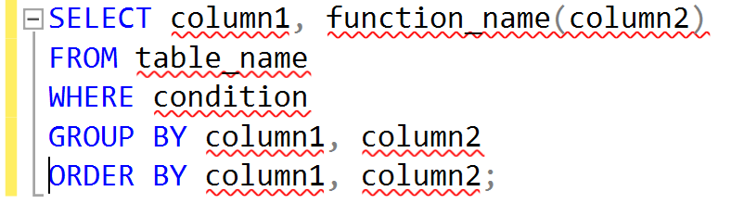

Example:

Display the number of students from each course.

First of all, you need to check the student table by following simple query. Then you can view the full Student table. It’s helpful to write a suitable query for the above question.

Then we can see following table.

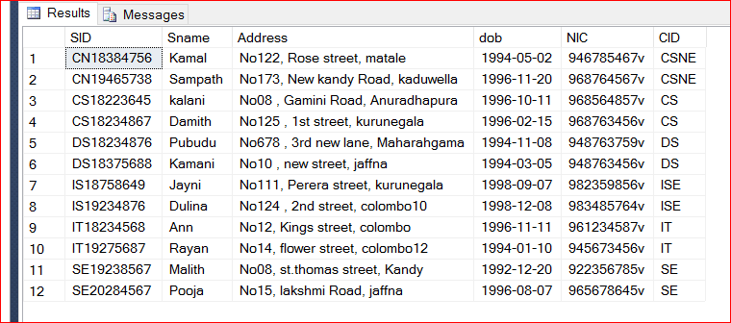

Now you can write down following SQL query to get the answer for the above question.

Section 2

Exercise

* 1. Display the total number of modules in each course?

SELECT COUNT (Cname)

FROM Course;

* 1. How many students are there for each course? Re name the count as ‘Number of Student’.

SELECT CID, COUNT(SID) AS 'No Of Modules'

FROM Student

GROUP BY CID;

* 1. What is the number of Modules offered by each course in each academic year?

SELECT Accadamic_year,CID, COUNT(Mcode) AS 'No of Module'

FROM Offers

GROUP BY Accadamic_year, CID;

* 1. What is the number of Modules in Semester 02 only?

SELECT Accadamic_year,CID, COUNT(Mcode) AS 'No of Module'

FROM Offers

WHERE Semester=2

GROUP BY Accadamic_year, CID;

* 1. Sort the results of Question (d.) according to the ascending order of CID.

SELECT Accadamic_year,CID, COUNT(Mcode) AS 'No of Module'

FROM Offers

WHERE Semester=2

GROUP BY Accadamic_year, CID

ORDER BY CID;